**OSI Layers**

OSI (Open Systems Interconnection) is a reference model for how applications communicate over a [network](https://searchnetworking.techtarget.com/definition/network).

A reference model is a conceptual framework for understanding relationships. The purpose of the OSI reference model is to guide vendors and developers so the digital communication products and software programs they create can [interoperate](https://searchmicroservices.techtarget.com/definition/interoperability), and to facilitate a clear framework that describes the functions of a networking or telecommunication system.

Most vendors involved in telecommunications make an attempt to describe their products and services in relation to the OSI model. And although it is useful for guiding discussion and evaluation, OSI is rarely actually implemented as-is. That's because few network products or standard tools keep related functions together in well-defined layers, as is the case in the OSI model. The [TCP/IP](https://searchnetworking.techtarget.com/definition/TCP-IP) protocol suite, which defines the internet, does not map cleanly to the OSI model.

**How the OSI model works**

IT professionals use OSI to model or trace how data is sent or received over a network. This model breaks down data transmission over a series of seven layers, each of which is responsible for performing specific tasks concerning sending and receiving data.

The main concept of OSI is that the process of communication between two endpoints in a network can be divided into seven distinct groups of related functions, or layers. Each communicating user or program is on a device that can provide those seven layers of function.

In this architecture, each layer serves the layer above it and, in turn, is served by the layer below it. So, in a given message between users, there will be a flow of data down through the layers in the source computer, across the network, and then up through the layers in the receiving computer. Only the application layer, at the top of the stack, doesn’t provide services to a higher-level layer.

The seven layers of function are provided by a combination of applications, [operating systems](https://whatis.techtarget.com/definition/operating-system-OS), network card device drivers and networking hardware that enable a system to transmit a signal over a network Ethernet or fiber optic cable or through [Wi-Fi](https://searchmobilecomputing.techtarget.com/definition/Wi-Fi) or other [wireless protocols](https://searchmobilecomputing.techtarget.com/definition/IEEE-802-Wireless-Standards-Fast-Reference).

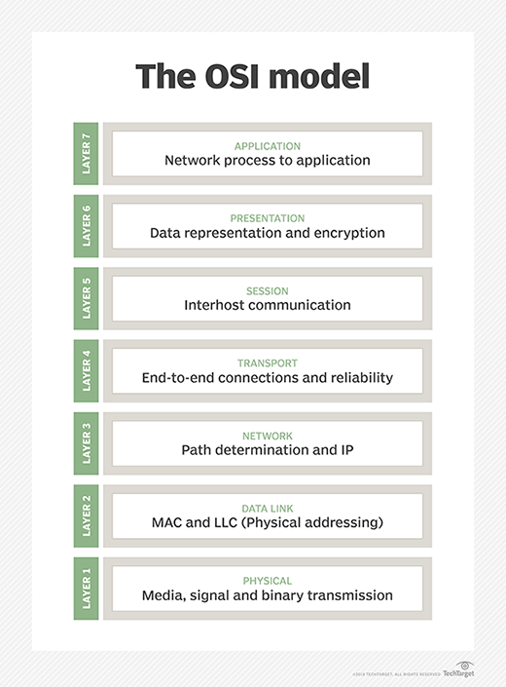

TechTarget

**7 layers of the OSI model**

The seven Open Systems Interconnection layers are:

[Layer 7: The application layer](https://searchnetworking.techtarget.com/definition/Application-layer): Enables the user (human or software) to interact with the application or network whenever the user elects to read messages, transfer files or perform other network-related activities. Web browsers and other internet-connected apps, such as Outlook and Skype, use Layer 7 application protocols.

[Layer 6: The presentation layer](https://searchnetworking.techtarget.com/definition/presentation-layer): Translates or formats data for the application layer based on the semantics or syntax that the application accepts. This layer is also able to handle the encryption and decryption that the application layer requires.

[Layer 5: The session layer](https://searchnetworking.techtarget.com/definition/Session-layer): Sets up, coordinates and terminates conversations between applications. Its services include authentication and reconnection after an interruption. This layer determines how long a system will wait for another application to respond. Examples of session layer protocols include [X.225](https://whatis.techtarget.com/definition/ITU-X225), AppleTalk and Zone Information Protocol (ZIP).

[Layer 4: The transport layer](https://searchnetworking.techtarget.com/definition/Transport-layer): Is responsible for transferring data across a network and provides error-checking mechanisms and data flow controls. It determines how much data to send, where it gets sent and at what rate. The Transmission Control Protocol is the best known example of the transport layer.

[Layer 3: The network layer](https://searchnetworking.techtarget.com/definition/Network-layer): Primary function is to move data into and through other networks. Network layer protocols accomplish this by packaging data with correct network address information, selecting the appropriate network routes and forwarding the packaged data up the stack to the transport layer.

[Layer 2: The data-link layer](https://searchnetworking.techtarget.com/definition/Data-Link-layer): The [protocol layer](https://searchnetworking.techtarget.com/definition/protocol) in a program that handles the moving of data into and out of a physical link in a network. This layer handles problems that occur as a result of bit transmission errors. It ensures that the pace of the data flow doesn’t overwhelm the sending and receiving devices. This layer also permits the transmission of data to Layer 3, the [network layer](https://searchnetworking.techtarget.com/definition/Network-layer), where it is addressed and routed.

[Layer 1: The physical layer](https://searchnetworking.techtarget.com/definition/physical-layer): Transports data using electrical, mechanical or procedural interfaces. This layer is responsible for sending computer bits from one device to another along the network. It determines how physical connections to the network are set up and how bits are represented into predictable signals as they are transmitted either electrically, optically or via radio waves.

**Cross layer functions**

Cross-layer functions, services that may affect more than one layer, include:

* Security service (telecommunication) as defined by ITU-T X.800 recommendation.
* Management functions -- functions that enable the configuration, instantiation, monitoring and terminating of the communications of two or more entities.
* Multiprotocol Label Switching ([MPLS](https://searchnetworking.techtarget.com/definition/Multiprotocol-Label-Switching-MPLS)) -- operates at an OSI-model layer that lies between layer 2 (data link layer) and layer 3 (network layer). MPLS can be used to carry a variety of traffic, including Ethernet frames and IP packets.
* ARP -- translates IPv4 addresses (OSI layer 3) into Ethernet MAC addresses (OSI layer 2).
* Domain name service – an application layer service used to look up the IP address of a domain name.

**History of the OSI model**

Developed by representatives of major computer and telecommunication companies beginning in 1983, OSI was originally intended to be a detailed specification of actual [interfaces](https://whatis.techtarget.com/definition/interface). Instead, the committee decided to establish a common reference model that others could then use to develop detailed interfaces, which, in turn, could become [standards](https://whatis.techtarget.com/definition/standard) governing the transmission of data packets. The OSI architecture was officially adopted as an international standard by the International Organization for Standardization ([ISO](https://searchdatacenter.techtarget.com/definition/ISO)) in 1984.

**OSI model vs. TCP/IP model**

OSI is a reference model that describes the functions of a telecommunication or networking system, while TCP/IP is a suite of communication protocols used to interconnect network devices on the internet. TCP/IP and OSI are the most broadly used networking models for communication.

The OSI and TCP/IP models have similarities and differences. The main similarity is in their construction as both use layers, although the OSI model consists of seven layers, while TCP/IP consists of just four layers.

Another similarity is that the upper layer for each model is the application layer, which performs the same tasks in each model, but may vary according to the information each receives.

The functions performed in each model are also similar because each uses a network layer and transport to operate. The OSI and TCP/IP model are each mostly used to transmit data packets. Although they will do so by different means and by different paths, they will still reach their destinations.

The OSI and TCP/IP models are similar in that they:

* are logical models.
* define standards for networking.
* divide the network communication process in layers.
* provide frameworks for creating and implementing networking standards and devices.
* enable one manufacturer to make devices and network components that can coexist and work with the devices and components made by other manufacturers.
* divide complex functions into simpler components.

Differences between the OSI model and TCP/IP model include:

* OSI has seven layers while the TCP/IP has four layers.
* OSI uses three layers (application, presentation and session) to define the functionality of upper layers, while TCP/IP uses just one layer (application).
* OSI uses two separate layers (physical and data link) to define the functionality of the bottom layers while TCP/IP uses one layer (link).
* OSI uses the network layer to define the routing standards and protocols, while TCP/IP uses the Internet layer.

**Pros and cons of the OSI model**

The OSI model has a number of advantages, including:

* It’s considered a standard model in computer networking.
* Supports connectionless as well as connection-oriented services. Users can leverage connectionless services when they need faster data transmissions over the internet and the connection-oriented model when they’re looking for reliability.
* Has the flexibility to adapt to many protocols
* More adaptable and secure than having all services bundled in one layer.

The disadvantages include:

* Doesn’t define any particular protocol.
* Session layer, which is used for session management, and the presentation layer, which deals with user interaction aren’t as useful as other layers in the OSI model.
* Some services are duplicated at various layers, such as the transport and data link layers each have an error control mechanism.
* Layers can’t work in parallel; each layer has to wait to receive data from the previous layer.

**Related Terms**

[**DHCP (Dynamic Host Configuration Protocol)**](https://searchnetworking.techtarget.com/definition/DHCP)

DHCP (Dynamic Host Configuration Protocol) is a network management protocol used to dynamically assign an Internet Protocol (IP) ...[See complete definition](https://searchnetworking.techtarget.com/definition/DHCP)

[**FTP (File Transfer Protocol)**](https://searchnetworking.techtarget.com/definition/File-Transfer-Protocol-FTP)

File Transfer Protocol (FTP) is a client-server standard used to transfer files between computers over the Internet using control...[See complete definition](https://searchnetworking.techtarget.com/definition/File-Transfer-Protocol-FTP)

[**Network Protocols**](https://searchnetworking.techtarget.com/definition/protocol)

Network protocols are sets of established rules that dictate how to format, transmit and receive data so computer network devices...[See complete definition](https://searchnetworking.techtarget.com/definition/protocol)

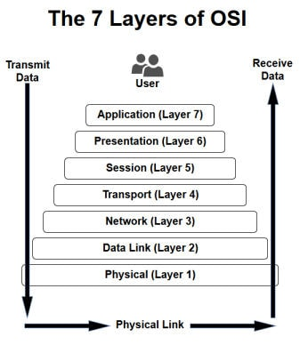

***Did You Know...?*** Most of the functionality in the OSI model exists in all communications systems, although two or three OSI layers may be incorporated into one. OSI is also referred to as the OSI Reference Model or just the OSI Model.

## *Application (Layer 7)*

OSI Model, Layer 7, supports [application](https://www.webopedia.com/TERM/A/application.html) and end-user processes. Communication partners are identified, quality of service is identified, user authentication and privacy are considered, and any constraints on data [syntax](https://www.webopedia.com/TERM/S/syntax.html) are identified. Everything at this layer is application-specific. This layer provides application services for file transfers, [e-mail](https://www.webopedia.com/TERM/E/e_mail.html), and other [network](https://www.webopedia.com/TERM/N/network.html) [software](https://www.webopedia.com/TERM/S/software.html) services. [Telnet](https://www.webopedia.com/TERM/T/Telnet.html) and [FTP](https://www.webopedia.com/TERM/F/ftp.html) are applications that exist entirely in the application level. Tiered application architectures are part of this layer.

Webopedia Study Guide Section Layer 7 Application examples include WWW browsers, NFS, SNMP, Telnet, HTTP, FTP

## *Presentation (Layer 6)*

This layer provides independence from differences in data representation (e.g., [encryption](https://www.webopedia.com/TERM/E/encryption.html)) by translating from application to network format, and vice versa. The presentation layer works to transform data into the form that the application layer can accept. This layer formats and encrypts data to be sent across a [network](https://www.webopedia.com/TERM/N/network.html), providing freedom from compatibility problems. It is sometimes called the syntax layer.

Webopedia Study Guide Section Layer 6 Presentation examples include encryption, ASCII, EBCDIC, TIFF, GIF, PICT, JPEG, MPEG, MIDI.

## *Session (Layer 5)*

This layer establishes, manages and terminates connections between [applications](https://www.webopedia.com/TERM/A/application.html). The session layer sets up, coordinates, and terminates conversations, exchanges, and dialogues between the applications at each end. It deals with session and connection coordination.

Webopedia Study Guide Section Layer 5 Session examples include NFS, NetBios names, RPC, SQL.

## *Transport (Layer 4)*

OSI Model, Layer 4, provides transparent transfer of data between end systems, or [hosts](https://www.webopedia.com/TERM/H/host.html), and is responsible for end-to-end error recovery and [flow control](https://www.webopedia.com/TERM/F/flow_control.html). It ensures complete data transfer.

Webopedia Study Guide Section Layer 4 Transport examples include SPX, TCP, UDP.

## *Network (Layer 3)*

Layer 3 provides [switching](https://www.webopedia.com/TERM/P/packet_switching.html) and [routing](https://www.webopedia.com/TERM/R/routing.html) technologies, creating logical paths, known as [virtual circuits](https://www.webopedia.com/TERM/V/virtual_circuit.html), for transmitting data from [node](https://www.webopedia.com/TERM/N/node.html) to node. Routing and forwarding are functions of this layer, as well as [addressing](https://www.webopedia.com/DidYouKnow/Internet/IPaddressing.asp), [internetworking](https://www.webopedia.com/TERM/I/internetworking.html), error handling, [congestion](https://www.webopedia.com/TERM/C/congestion.html) control and packet sequencing.

Webopedia Study Guide Section Layer 3 Network examples include AppleTalk DDP, IP, IPX.

## *Data Link (Layer 2)*

At OSI Model, Layer 2, data packets are [encoded](https://www.webopedia.com/TERM/E/encoding.html) and decoded into bits. It furnishes [transmission protocol](https://www.webopedia.com/TERM/T/TCP_IP.html)knowledge and management and handles errors in the physical layer, flow control and frame synchronization. The data link layer is divided into two sub layers: The Media Access Control ([MAC](https://www.webopedia.com/TERM/M/MAC_address.html)) layer and the [Logical Link Control](https://www.webopedia.com/TERM/L/Logical_Link_Control_layer.html)(LLC) layer. The MAC sub layer controls how a computer on the network gains access to the data and permission to transmit it. The LLC layer controls frame [synchronization](https://www.webopedia.com/TERM/D/data_synchronization.html), flow control and error checking.

Webopedia Study Guide Section Layer 2 Data Link examples include PPP, FDDI, ATM, IEEE 802.5/ 802.2, IEEE 802.3/802.2, HDLC, Frame Relay.

## *Physical (Layer 1)*

OSI Model, Layer 1 conveys the bit stream - electrical impulse, light or radio signal — through the [network](https://www.webopedia.com/TERM/N/network.html) at the electrical and mechanical level. It provides the [hardware](https://www.webopedia.com/TERM/H/hardware.html) means of sending and receiving data on a carrier, including defining cables, cards and physical aspects. [Fast Ethernet](https://www.webopedia.com/TERM/1/100Base_T.html), [RS232](https://www.webopedia.com/TERM/R/RS_232C.html), and [ATM](https://www.webopedia.com/TERM/A/ATM.html) are [protocols](https://www.webopedia.com/TERM/P/protocol.html) with physical layer components.

Webopedia Study Guide Section Layer 1 Physical examples include Ethernet, FDDI, B8ZS, V.35, V.24, RJ45.

***DID YOU KNOW....?*** Two similar projects from the late 1970's were merged in 1983 to form the Basic Reference Model for Open Systems Interconnection standard (the OSI model). It was published in 1984 as standard ISO 7498.